Distributed Version Control System (DVCS)
# Source: AI Source: Provided by: [Data Path: Persons Table -> ID Column: 1, Name_En Column: Motasem Essam] -> From: [ChatGPT] on [2/15/2026]
A Distributed Version Control System (DVCS) is a type of version control system where every developer has a full copy of the entire code history — not just the current version — on their own machine.

🧠 In Simple Terms:
# Source: AI Source: Provided by: [Data Path: Persons Table -> ID Column: 1, Name_En Column: Motasem Essam] -> From: [ChatGPT] on [2/15/2026]
Instead of one central server holding the code, everyone has their own complete copy of the repository.

🔧 What Version Control Means First
# Source: AI Source: Provided by: [Data Path: Persons Table -> ID Column: 1, Name_En Column: Motasem Essam] -> From: [ChatGPT] on [2/15/2026]
Version control helps track changes to code over time — so you can:
- 📜 See who changed what and when
- 🔁 Roll back to earlier versions
- 🤝 Collaborate with others safely

🔄 Centralized vs Distributed
# Source: AI Source: Provided by: [Data Path: Persons Table -> ID Column: 1, Name_En Column: Motasem Essam] -> From: [ChatGPT] on [2/15/2026]
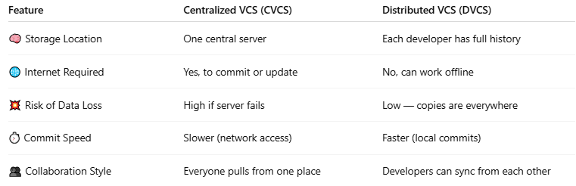

Feature | Centralized VCS (CVCS) | Distributed VCS (DVCS)
🧠 Storage Location | One central server | Each developer has full history
🌐 Internet Required | Yes, to commit or update | No, can work offline
💥 Risk of Data Loss | High if server fails | Low — copies are everywhere
⏱️ Commit Speed | Slower (network access) | Faster (local commits)
👥 Collaboration Style | Everyone pulls from one place | Developers can sync from each other

🛠️ Popular Distributed Version Control Systems
# Source: AI Source: Provided by: [Data Path: Persons Table -> ID Column: 1, Name_En Column: Motasem Essam] -> From: [ChatGPT] on [2/15/2026]
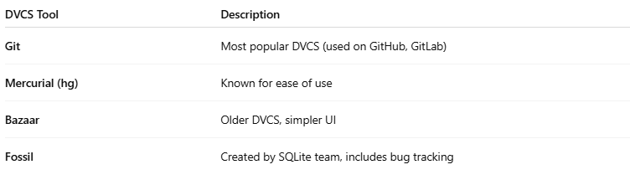

DVCS Tool | Description
Git | Most popular DVCS (used on GitHub, GitLab)
Mercurial (hg) | Known for ease of use
Bazaar | Older DVCS, simpler UI
Fossil | Created by SQLite team, includes bug tracking

✅ How Git (a DVCS) Works — Simplified
# Source: AI Source: Provided by: [Data Path: Persons Table -> ID Column: 1, Name_En Column: Motasem Essam] -> From: [ChatGPT] on [2/15/2026]
- You clone a repository:
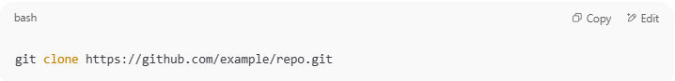
git clone https://github.com/example/repo.git
🔽 Now you have:
  - The latest version of the code
  - Full history of every change
- You make local changes and commit:
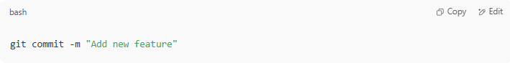
git commit -m "Add new feature"
✅ No internet needed — it's saved locally
- Later, you push to the central server:
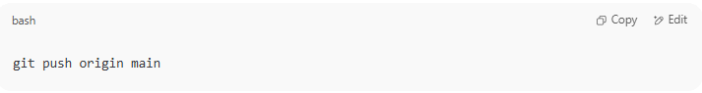
git push origin main

🧠 Why Use DVCS?
# Source: AI Source: Provided by: [Data Path: Persons Table -> ID Column: 1, Name_En Column: Motasem Essam] -> From: [ChatGPT] on [2/15/2026]
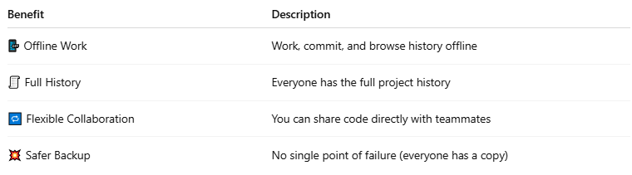

Benefit | Description
📴 Offline Work | Work, commit, and browse history offline
🧾 Full History | Everyone has the full project history
🔁 Flexible Collaboration | You can share code directly with teammates
💥 Safer Backup | No single point of failure (everyone has a copy)

🔚 In Summary:
# Source: AI Source: Provided by: [Data Path: Persons Table -> ID Column: 1, Name_En Column: Motasem Essam] -> From: [ChatGPT] on [2/15/2026]
A Distributed Version Control System (DVCS):
- Lets every developer keep a full history of a project
- Allows offline commits
- Offers faster and safer collaboration than centralized systems

